**JFo Section 2 Practice**

* B. Rishitha

192324130

**QUESTION:**

**ProblemSet2_1**

**public class ProblemSet2_1 {**

**public static void main(String[] args) {**

**// Use 8 print statements to print a smiley face.**

**// The art will rely on only a single character, besides space, such as X or #.**

**System.out.println(&quot; ##### &quot;);**

**System.out.println(&quot; # # &quot;);**

**System.out.println(&quot;# # # #&quot;);**

**System.out.println(&quot;# #&quot;);**

**System.out.println(&quot;# ### #&quot;);**

**System.out.println(&quot;# ### #&quot;);**

**System.out.println(&quot; # # &quot;);**

**System.out.println(&quot; ##### &quot;);**

**}**

**}**

**Problem set2_2**

**ASCII art is a graphic design technique that uses printable characters from the ASCII standard to**

**create images and designs. ASCII (American Standard Code for Information Interchange)**

**includes 128 characters, such as letters, numbers, punctuation marks, and control characters. By**

**carefully arranging these characters, artists can create detailed images, patterns, and**

**representations of objects.**

**public class ProblemSet2_2 {**

**public static void main(String[] args) {**

**// This ASCII art depicts a simple house with a roof, a door, and windows.**

**System.out.println(&quot; /\\ &quot;);**

**System.out.println(&quot; / \\ &quot;);**

**System.out.println(&quot; /____\\ &quot;);**

**System.out.println(&quot; | | &quot;);**

**System.out.println(&quot; | [] | &quot;);**

**System.out.println(&quot; |____| &quot;);**

**}**

**}**

**ANSWER:**

**CODE:**

**public class ProblemSet2_1 {**

**public static void main(String[] args) {**

**System.out.println(" ##### ");**

**System.out.println(" # # ");**

**System.out.println("# # # #");**

**System.out.println("# #");**

**System.out.println("# ### #");**

**System.out.println("# ### #");**

**System.out.println(" # # ");**

**System.out.println(" ##### ");**

**}**

**}**

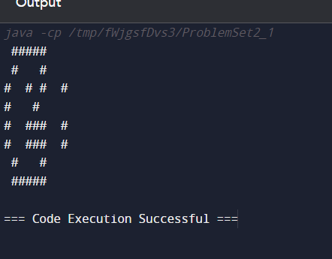

**System.out.println(&quot; /\\ &quot;);**

**System.out.println(&quot; / \\ &quot;);**

**System.out.println(&quot; /____\\ &quot;);**

**System.out.println(&quot; | | &quot;);**

**System.out.println(&quot; | [] | &quot;);**

**System.out.println(&quot; |____| &quot;);**

**}**

**}**

**public class ProblemSet2_2 {**

**public static void main(String[] args) {**

**// This ASCII art depicts a simple house with a roof, a door, and windows.**

**System.out.println(" /\\ ");**

**System.out.println(" / \\ ");**

**System.out.println(" /____\\ ");**

**System.out.println(" | | ");**

**System.out.println(" | [] | ");**

**System.out.println(" |____| ");**

**}**

**}**

